Generic Hardware Access in Linux

Generic hardware interfacing
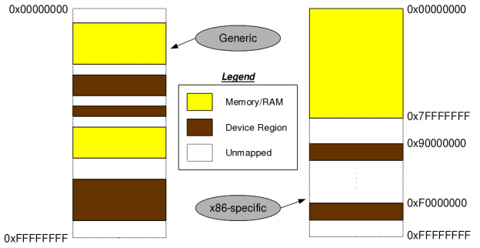

Figure: Hardware mapping

The basic assumption being that the architecture is 32-bit. For others, the memory map would change accordingly. For 32-bit address bus, the address/memory map ranges from 0 (0x00000000) to ‘2^32– 1′ (0xFFFFFFFF). And an architecture independent layout of this memory map would be as shown in the Figure 11 – memory (RAM) and device regions (registers & memories of devices) mapped in an interleaved fashion. The architecture dependent thing would be what these addresses are actually there. For example, in an x86 architecture, the initial 3GB (0x00000000 to 0xBFFFFFFF) is typically for RAM and the later 1GB (0xC0000000 to 0xFFFFFFFF) for device maps. However, if the RAM is less, say 2GB, device maps could start from 2GB (0x80000000).

Type in cat /proc/iomem to list the memory map on your system. cat /proc/meminfo would give you an approximate RAM size on your system. Refer to Figure for a snapshot.

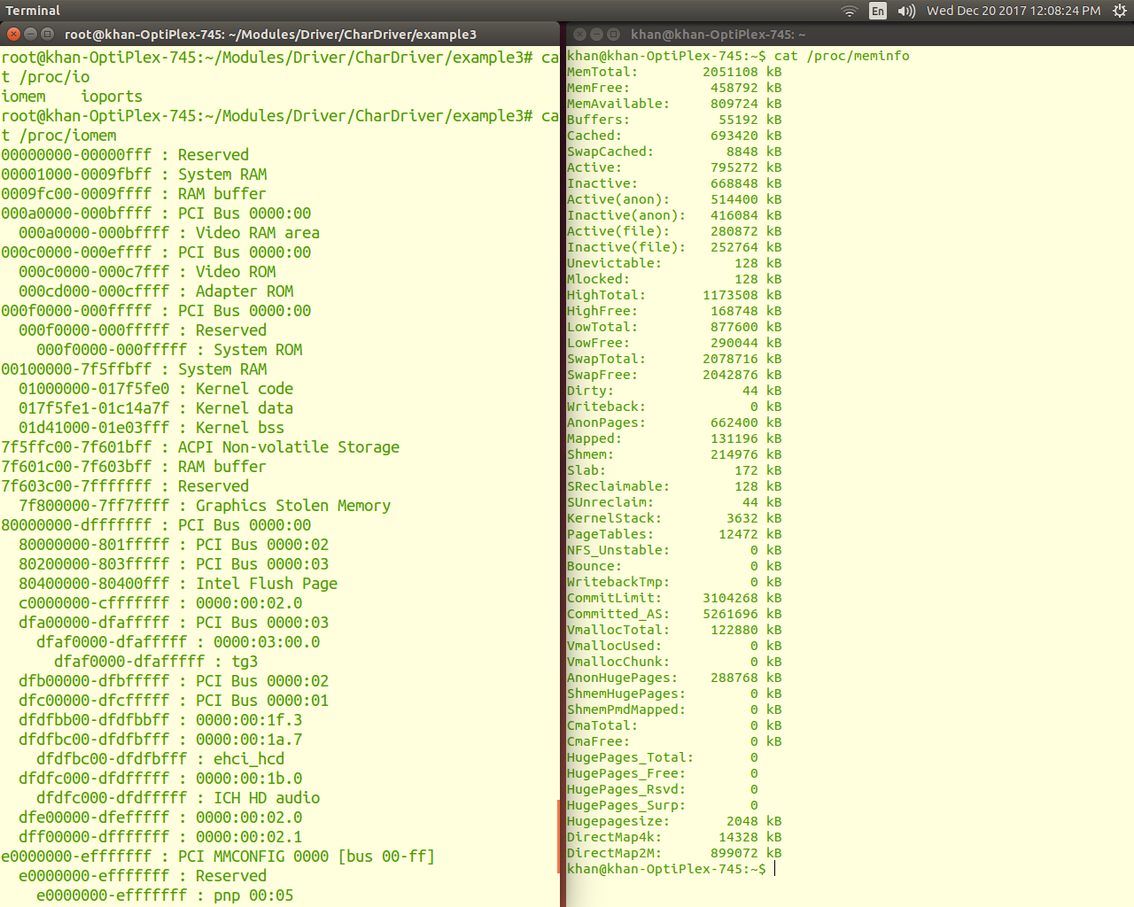
Irrespective of the actual values, the addresses referring to RAM are termed as physical addresses. And the addresses referring to device maps are termed as bus addresses, as these devices are always mapped through some architecture-specific bus. For example, PCI bus in x86 architecture, AMBA bus in ARM architectures, SuperHyway bus in SuperH (or SH) architectures, GX bus on PowerPC (or PPC), etc.

All the architecture dependent values of these physical and bus addresses are either dynamically configurable or are to be obtained from the datasheets (i.e. hardware manuals) of the corresponding architecture processors/controllers. But the interesting part is that, in Linux none of these are directly accessible but are to be mapped to virtual addresses and then accessed through that. Thus, making the RAM and device accesses generic enough, except just mapping them to virtual addresses. And the corresponding APIs for mapping & unmapping the device bus addresses to virtual addresses are:
#include <asm/io.h>
void *ioremap(unsigned long device_bus_address, unsigned long device_region_size);
void iounmap(void *virt_addr);

These are prototyped in <asm/io.h>. Once mapped to virtual addresses, it boils down to the device datasheet, as to which set of device registers and/or device memory to read from or write into, by adding their offsets to the virtual address returned by ioremap(). For that, the following are the APIs (prototyped in the same header file <asm/io.h>):

#include <asm/io.h>
unsigned int ioread8(void *virt_addr);
unsigned int ioread16(void *virt_addr);
unsigned int ioread32(void *virt_addr);
unsigned int iowrite8(u8 value, void *virt_addr);
unsigned int iowrite16(u16 value, void *virt_addr);
unsigned int iowrite32(u32 value, void *virt_addr);

Accessing the video RAM of “DOS” days

After this first set of information, we will do live experiments. We experiment with the video RAM of “DOS” days to understand the usage of the above APIs.We got onto the system – displayed the /proc/iomem window – one very similar to as shown in Figure. From there, we got the video RAM address ranging from 0x000A0000 to 0x000BFFFF. And with that we added the above APIs with appropriate parameters into the constructor and destructor of our already written null driver to convert it into a vram driver. Then, we added the user access to the video RAM through read & write calls of the vram driver. Here’s what we coded in the new file video_ram.c:

example 4

Summing up

Then, we would repeat the following steps:

1. Build the vram driver (video_ram.ko file) by running make with the same Makefile changed to build this driver.

2. Usual load of the driver using insmod video_ram.ko.
3. Usual write into /dev/vram, say using echo -n “0123456789” > /dev/vram.
4. Read the /dev/vram contents using xxd /dev/vram | less. The usual cat /dev/vram also can be used but that would give all binary content. Xxd shows them up as hexadecimal in centre with the corresponding ASCII along the right side.
5. Usual unload the driver using rmmod video_ram.

Note 1: Today’s systems typically use separate video cards having their own video RAM. So, the video RAM used in the “DOS days”, i.e. the one mentioned in this article is unused and many a times not even present. Hence, playing around with it, is safe, without any effect on the system, or the display.

Note 2: Moreover, if the video RAM is absent, the read/write may not be actually reading/writing, but just sending/receiving signals in the air. In such a case, writes would not do any change, and reads would keep on reading the same value – thus ‘xxd’ showing the same values.

